1. **Write a Python Program to Display Fibonacci Sequence Using Recursion?**

**Ans:**

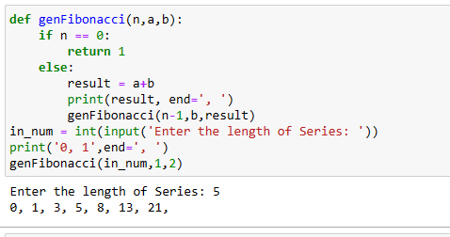

1. Write **a Python Program to Find Factorial of Number Using Recursion?**

**Ans:**

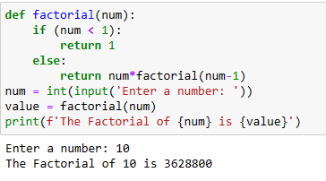

1. **Write a Python Program to calculate your Body Mass Index?**

**Ans:**

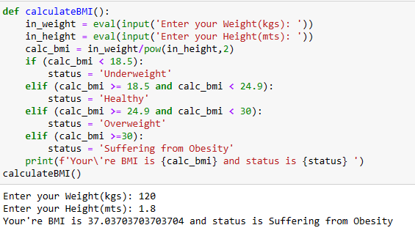

1. **Write a Python Program to calculate the natural logarithm of any number?**

**ans:**

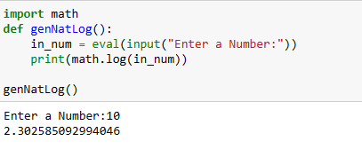

1. **Write a Python Program for cube sum of first n natural numbers?**

**Ans:**

